Enclosure 1: Module (Unit) Specification (MS)
Module Lists
No. | Module ID | Module Name
1 | CRR-TC-01 | User Identity Capture Verification
2 | CRR-TC-02 | Temporal Alignment Logic Verification
3 | IQ-TC-01 | Binary Integrity & Versioning Verification
4 | IQ-TC-02 | Directory Structure Verification
5 | IQ-TC-04 | Automated Folder Initialization
6 | IQ-TC-06 | Pre-Flight Integrity Check Failure

Module Specification
- User Identity Capture Verification (CRR-TC-01)
Module ID | CRR-TC-01
Module Name | User Identity Capture Verification
Description | The system securely and accurately captures the actual Windows username of the person running the application. This ensures that the Audit Trail history is always linked to a real person.
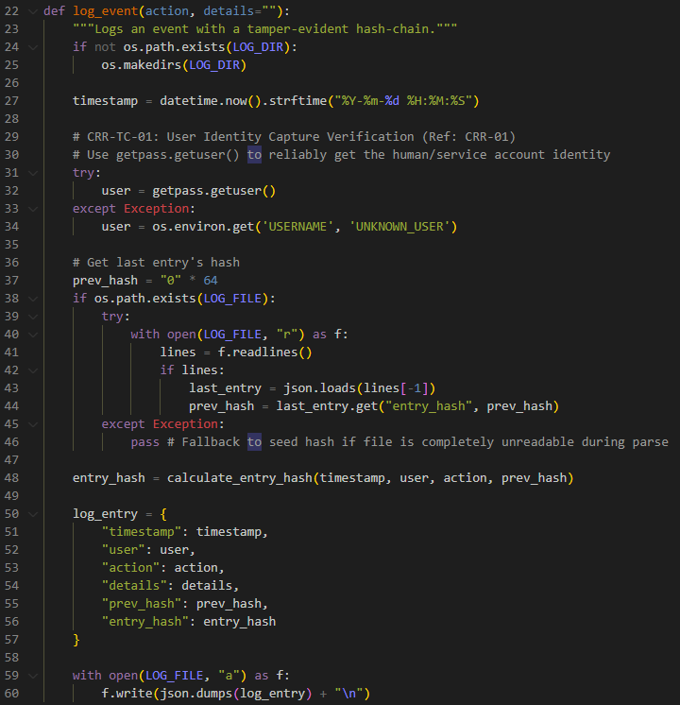
(Figure 01: Source Code for log_event Function (Reference: CRR-TC-01)

- Temporal Alignment Logic Verification (CRR-TC-02)
Module ID | CRR-TC-02
Module Name | Temporal Alignment Logic Verification
Description | The system aligns time-stamps properly when comparing pressure between two rooms, allowing a small 60-second window (tolerance) to account for slight delays in different sensors sending their data.
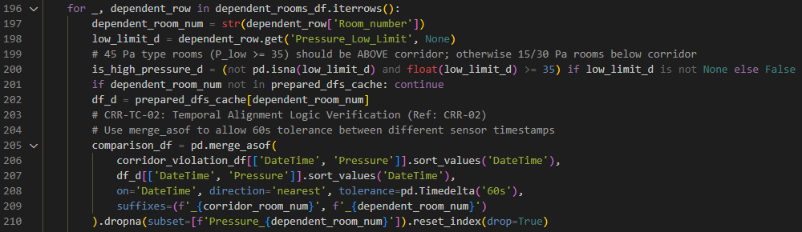
(Figure 02: Source Code for temporal alignment with 60s (Reference: CRR-TC-01)
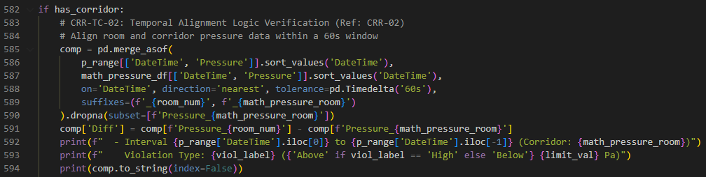
(Figure 03: Source Code for temporal alignment with 60s (Reference: CRR-TC-01)

- Binary Integrity & Versioning Verification (IQ-TC-01)
Module ID | IQ-TC-01
Module Name | Binary Integrity & Versioning Verification
Description | The delivered program (`AirQualityReview.exe`) is correctly installed, matches the officially validated software build, and contains the correct version information.
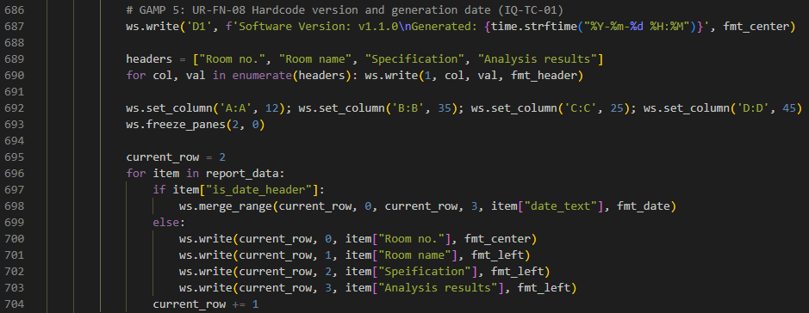
(Figure 04: Source Code for software version identify (Reference: IQ-TC-01)
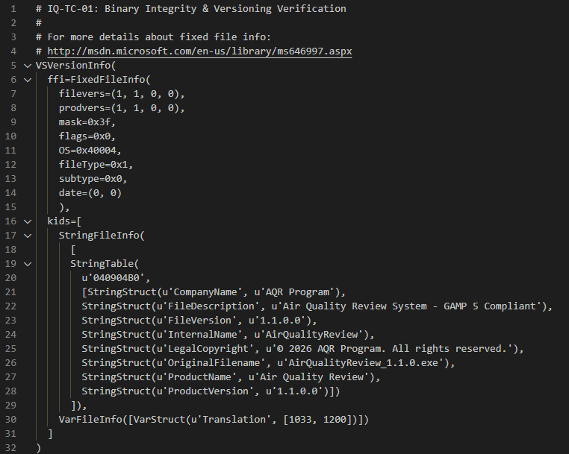
(Figure 05: Source Code for software version identify (Reference: IQ-TC-01)

- Directory Structure Verification (IQ-TC-02)
Module ID | IQ-TC-02
Module Name | Directory Structure Verification
Description | The system successfully sets up its own working environment by automatically creating the necessary folders and the core security log file the first time you run it.
- Automated Folder Initialization(IQ-TC-04)
Module ID | IQ-TC-04
Module Name | Automated Folder Initialization
Description | The system's ability to "self-heal". If critical folders are accidentally deleted by a user, the system must be able to automatically recreate them to prevent crashing.
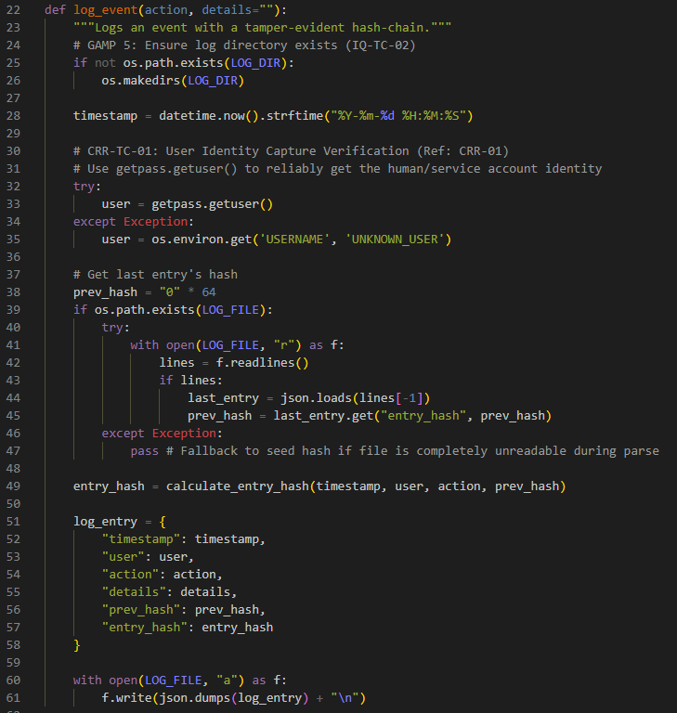
(Figure 06: Source Code for automatically creating folders and the core security log file (Reference: IQ-TC-02 and IQ-TC-04)
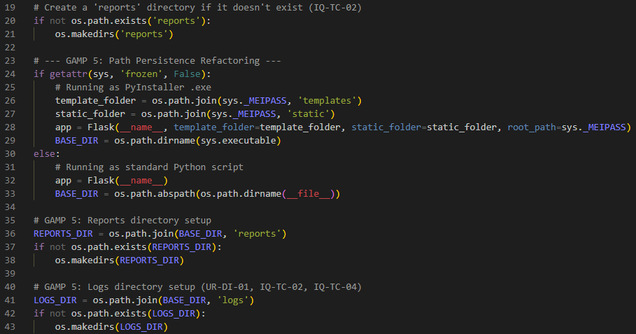
(Figure 07: Source Code for automatically creating folders and the core security log file (Reference: IQ-TC-02 and IQ-TC-04)

- Standalone Isolation Verification(IQ-TC-06)
Module ID | IQ-TC-04
Module Name | Standalone Isolation Verification
Description | The application is fully independent. It must be capable of executing all its core functions without relying on external internet connections or pre-installed programming software (like Python) on the user's computer.
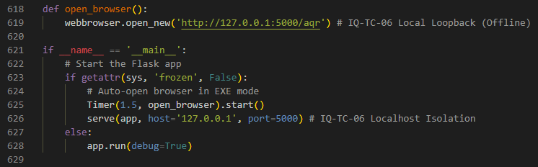
(Figure 08: Source Code for standalone isolation software (Reference: IQ-TC-06)

- Pre-Flight Integrity Check Failure(IQ-TC-07)
Module ID | IQ-TC-07
Module Name | Pre-Flight Integrity Check Failure
Description | The system has a robust self-protection mechanism. It must prevent the program from opening if it detects that the security history file (`audit_trail.log`) has been manually altered, ensuring compliance with strict data security rules (21 CFR Part 11).
